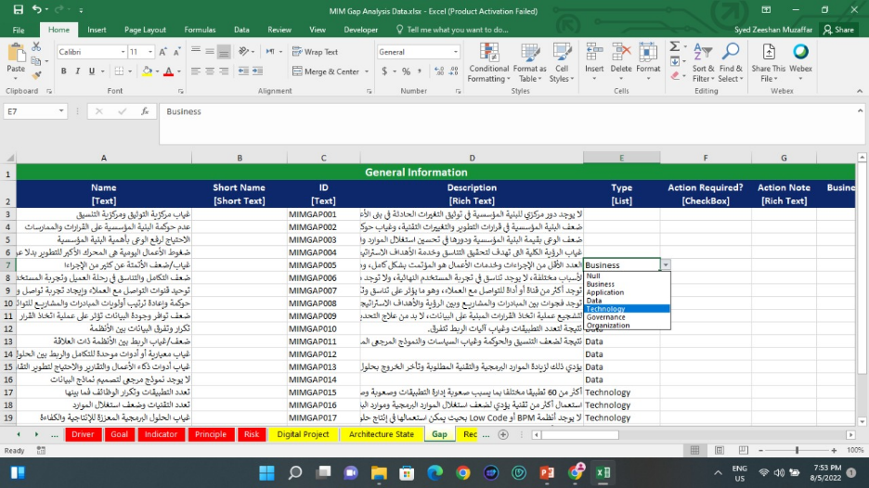

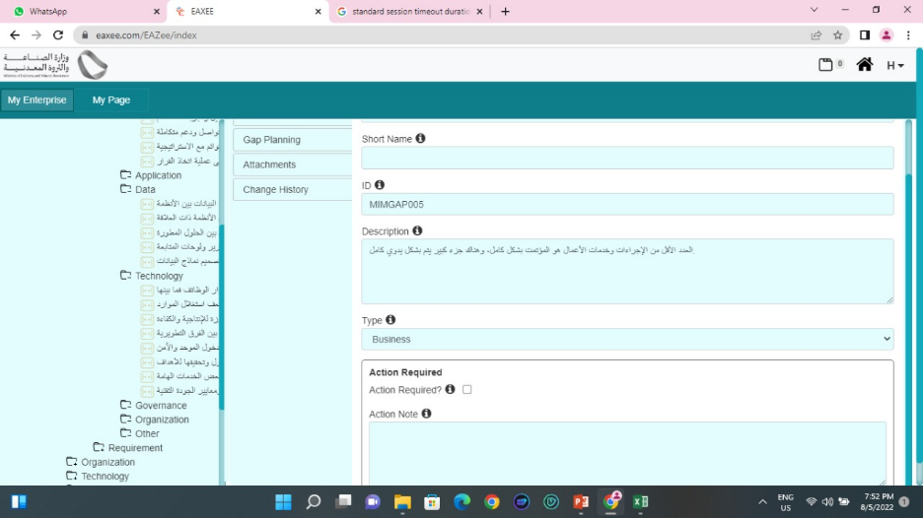

I imported GAP objects from attached excel

The object with 'Type' not assigned are not imported

The drop down for Type attribute in the Excel template exported from the tool doesn't contain 'Other' whereas it's present in the Objects hierarchy

Please resolve these bugs

Interestingly, when I tried to create the missing gaps manually in the tool, upon saving it said Name already exists. It seems that the gaps were created in the repository but not appearing in the tree. Please verify this and resolve

And I am right, the gaps were created in the repository and appear in the catalog. So, please resolve the bug

Another Bug: Admin is restricted to delete a folder in Models

Interestingly, upon refreshing the page the folder is gone

Please record all these bugs in bugs report and track their resolution

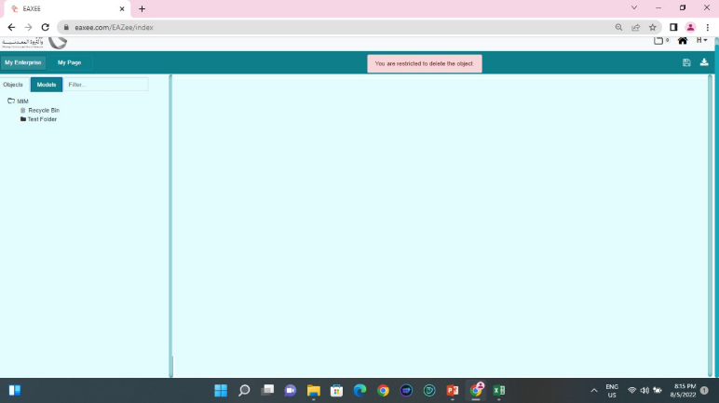

The Column 'Associated Objects' in the following catalog is copying data from 'Gap between Architecture States'. This is a bug. It must be empty because no relationships were created for this attribute.

